**Production variability Analysis - Manufacturing Sector**

GOKULNATH K & E24755

**Overview**

Production Variability Analysis in the manufacturing sector helps data analysts identify inconsistencies in production processes, such as cycle time fluctuations, yield variability, and machine performance. It involves using data-driven insights to detect root causes of inefficiencies and reduce downtime. By analyzing these factors, analysts can optimize production, improve quality, and reduce costs. This leads to more stable and efficient operations, enhancing overall productivity.

**Objective**

1. **Identify Production Inconsistencies:** Detect fluctuations in cycle times, throughput, and product quality.
2. **Analyze Root Causes:** Determine factors such as equipment performance, material quality, or operator efficiency that contribute to variability.
3. **Improve Process Stability:** Minimize variations to ensure consistent production output and quality.
4. **Optimize Efficiency and Costs:** Reduce downtime, waste, and rework to increase operational efficiency and lower production costs.
5. **Support Data-Driven Decision Making:** Provide actionable insights for continuous process improvements and proactive issue resolution.

**Assigned Task(s)**

* Production variability Analysis - Manufacturing Sector.
* **Status:** Completed.
* **Details:**

1. Cycle Time Variability Over Time: Line plot displaying fluctuations in cycle time for each machine, helping to identify trends and anomalies.
2. Average Downtime by Machine: Bar plot illustrating the average downtime for each machine, highlighting opportunities for maintenance and efficiency improvements.
3. Correlation Heatmap: Heatmap visualizing the correlation between defect counts and environmental factors (temperature, humidity), providing insights into quality control.
4. Cycle Time Distribution by Shift: Box plot representing the distribution of cycle times across different shifts, identifying performance variations that may require attention.
5. Defect Rate by Material Type: Bar plot showing defect rates associated with various material types, guiding decisions on material selection and supplier evaluations.
6. Shift-wise Defect Count: Visualization of defect counts aggregated by shift, assisting in identifying shifts that may require process improvements or additional training.

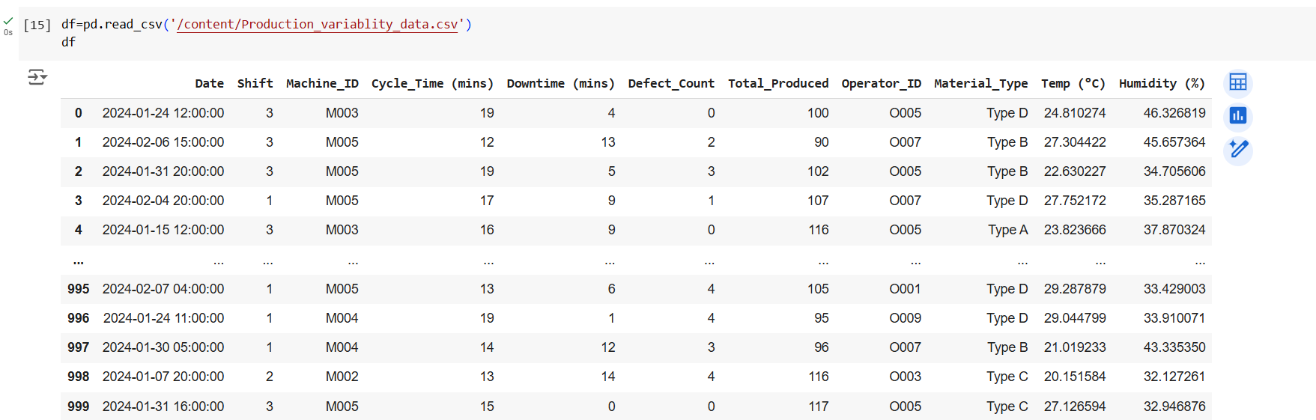

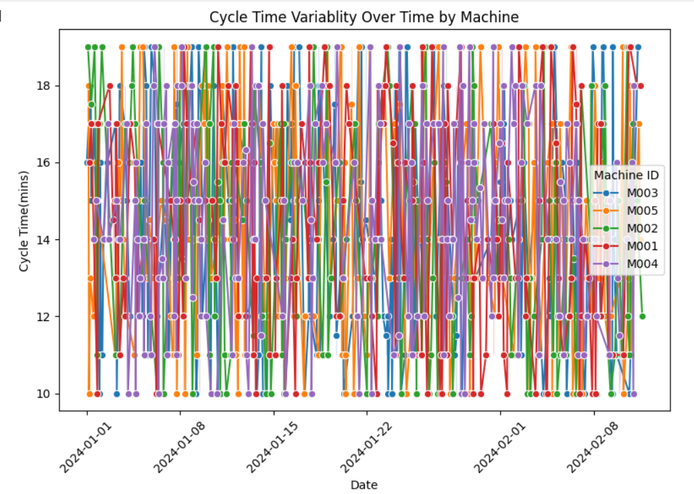

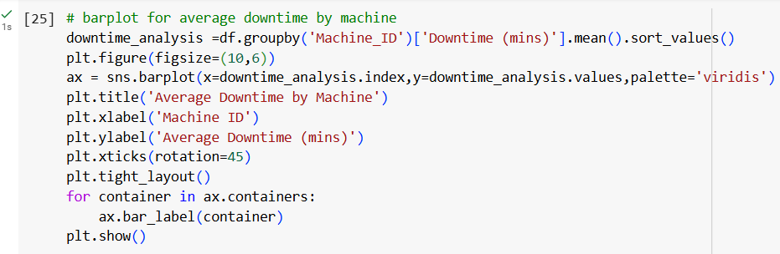

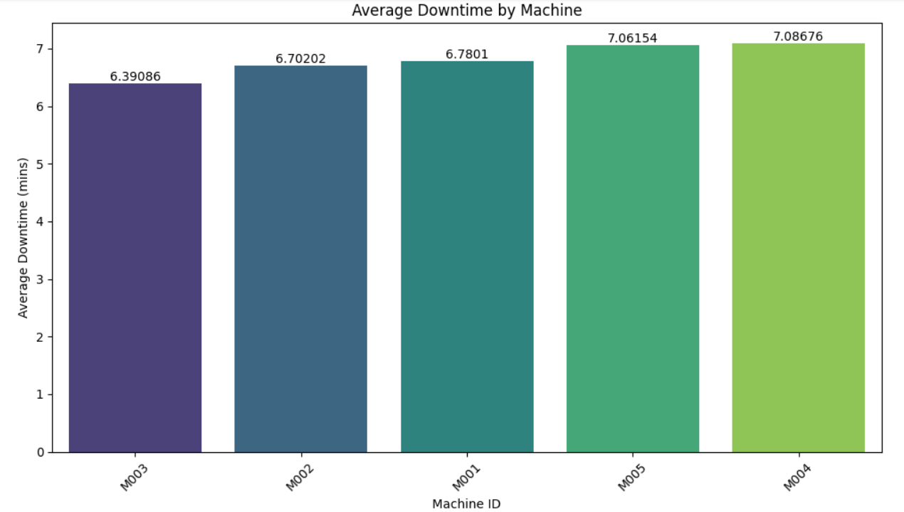

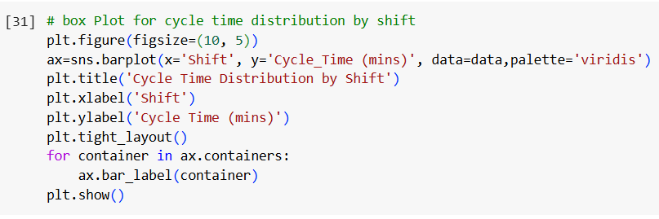

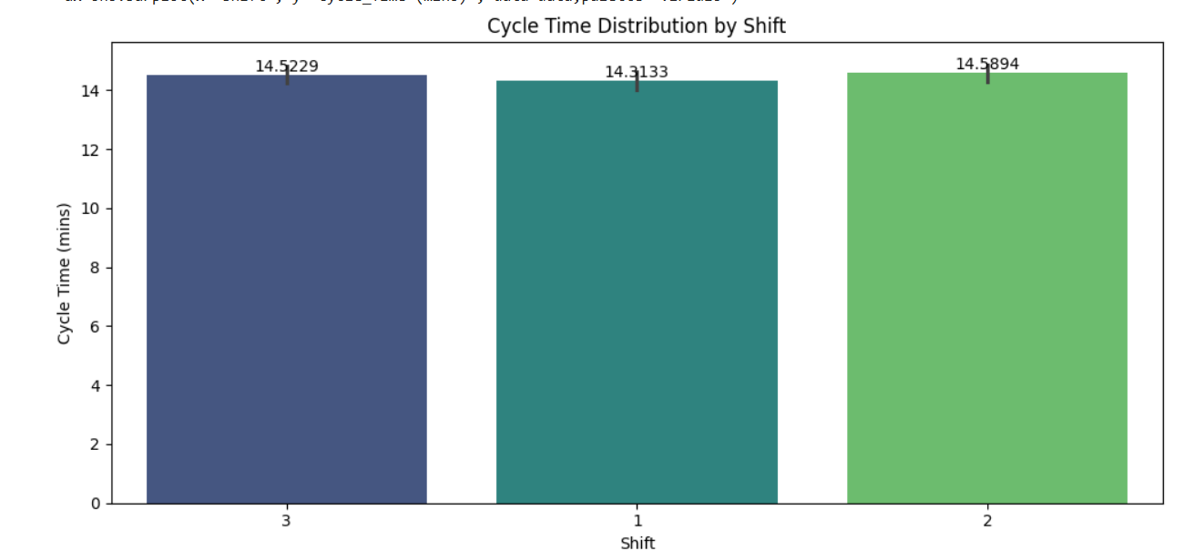

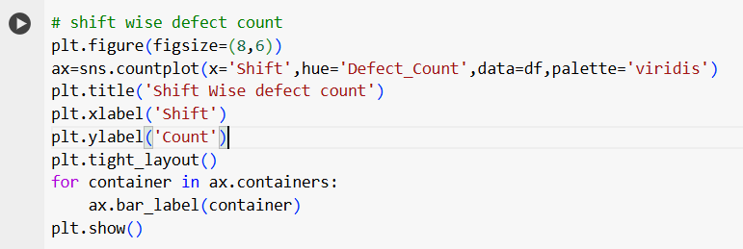

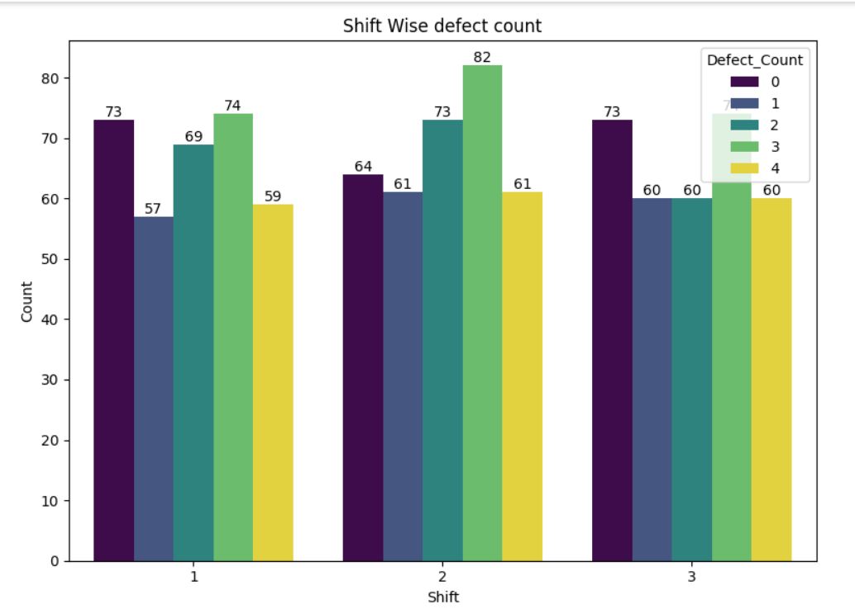

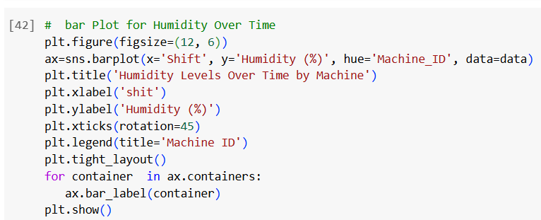

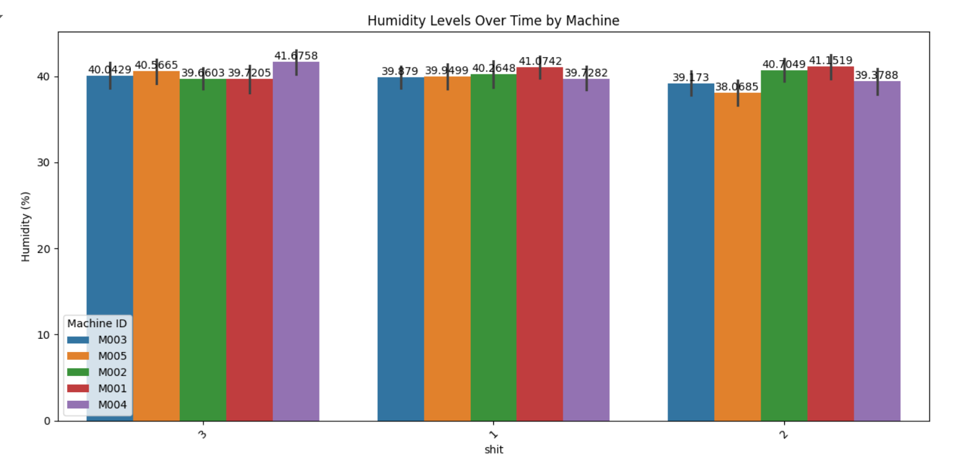

**Progress**

* **Accomplishments:**

1. Cycle Time Analysis: Developed a line plot to visualize cycle time variability over time by machine.
2. Downtime Assessment: Created a bar plot to display average downtime per machine for operational insights.
3. Defect Correlation Analysis: Generated a heatmap to explore correlations between defect counts and environmental factors.
4. Cycle Time Distribution Evaluation: Designed a box plot to assess cycle time distributions across shifts.
5. Material Quality Assessment: Produced a bar plot to evaluate defect rates by material type.
6. Shift Performance Monitoring: Visualized defect counts by shift to identify trends and improvement areas.

* **Metrics:**

1. Average Cycle Time: Measured the average cycle time for each machine, indicating production efficiency.
2. Average Downtime: Calculated the average downtime for each machine to assess operational performance.
3. Defect Rate: Evaluated defect rates per material type, providing insights into quality issues.
4. Correlation Coefficients: Analyzed correlation coefficients between defect counts and environmental factors (e.g., temperature, humidity) to identify influences on quality.
5. Cycle Time Variability: Assessed the range and interquartile range (IQR) of cycle times across shifts to identify performance consistency.
6. Defect Count by Shift: Tracked total defect counts for each shift to identify patterns and areas for improvement.

**Challenges and Solutions**

* **Challenges Faced:**

1. Encountered inconsistencies in data entry that affected analysis accuracy.
2. Understanding complex relationships between multiple environmental factors and defects required advanced analysis.

* **Solutions Implemented:**

1. Implemented data cleaning processes to standardize entries and improve accuracy.
2. Employed multivariate analysis techniques to better understand complex correlations.

**Next Steps**

* **Upcoming Tasks:** Regularly review progress against objectives and adjust strategies as needed.
* **Goals:** Conduct periodic evaluations of progress towards goals and adjust strategies as necessary.

**Conclusion**

* **Summary:** Production variability analysis in the manufacturing sector is crucial for identifying inefficiencies and quality issues. By leveraging data analytics, organizations can uncover trends and correlations, enabling informed decision-making. Implementing effective visualizations and metrics helps track performance and drive continuous improvement. Ultimately, this analysis supports enhanced operational efficiency and product quality, contributing to overall business success.
* **Acknowledgements:** Thank you all for your attention and engagement, I appreciate your interest in the Production variability analysis - Manufacturing Sector.